

TAGLINE

Information Technologies

Rough Order of Magnitude (ROM) Estimate

Prepared by: Canada IT Team

Portfolio Manager: *Riti Dole*

Request: 1464 - Ignite Marketplace Extract/Refresh automation CIBC

Requester:

*Oleksandra Ludan*

Created: October 09, 2019

Expires: December 09, 2019

IT process

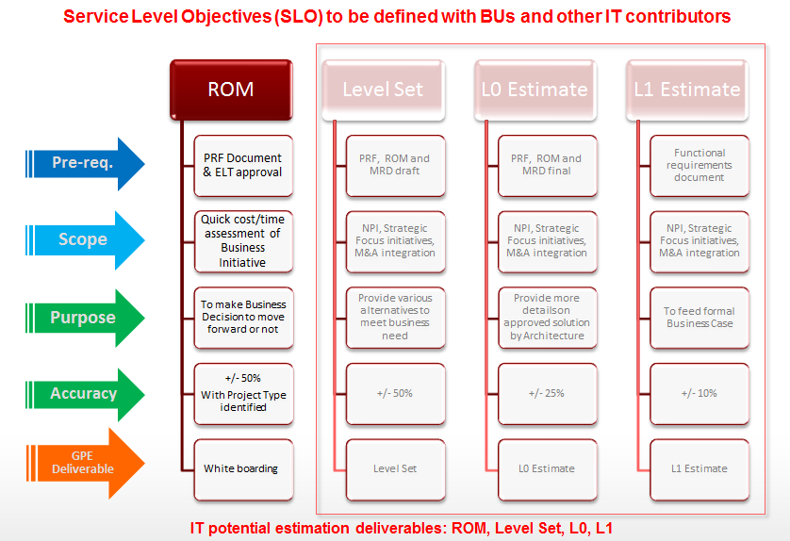

Intranet link to submit new requests to IT:

<http://central.eis.equifax.com/apps/canadait/Canada%20IT%20Requests/Lists/Projects/NewForm.aspx>

Business Context

Portfolio insights is a marketplace app lanched in March, 2019. The app's backend database currently is comprised of 5 CSV files that are manually created and plugged into the spotfire visual DXPs prior to loading in production - size 400-500MB in total.

Request is to migrate PI2 backend datastore from CSVs to relational DBs tables to take advantage of speed and performance.

This will also automate the data refreshing of the PI2 apps which currently is a manual task of D&A data team monthly creating new CSVs and replugging them in the Spotfire DXPS.

Benefits

Expected Revenues: 500k

Expected Cost Savings: NA

Expected Intangible Benefits: Performance and Speet of portfolio insights products in Ignite marketplace

Impact if no Action: Inability for product to get traction in market

Requirements

Please assist in extracting and sending information to the client in October, as well as assist in automating the process going forward by scheduling tasks associated with building files and sending to the clietn through SFTP on monthly basis.

Refer to the the following steps:

- Extract data from Cambrian PROD tables.

- Move this data to Spotfire DEV to update the reports.

- Promote data from Spotfire DEV to Spotfire PROD to refresh the Spotfire reports.

Thank you

High Level Scope of the Solution

At a high level, the solution proposes to define a data model, setup Oracle database and implement data model schema for PI 2.0. We will develop Oozie ETL flow and Hive scripts to populate the database for all customers and produce required outputs to be sent to each customer via the defined delivery channel. The existing Spotfire reports would be configured to use the new database so that the monthly data refresh for the customers could be automated.

The soultion could be divided into two parts. The first part will setup the base processes for PI 2.0 as a product in Ignite Marketplace. This is a one time effort for the PI 2.0 product. The second part is dedicated to configure each customer for PI 2.0.

Out of scope

* Setting up SFTP data transfer channel for the customer is out of scope for this request.

Assumptions

* It is assumed that the SFTP data transfer channel is already setup.
* Existing scripts/process to generate the PI 2.0 data in Cambrian shall be provided by D&A team.

Risks

* No significant risks that could impact costs or feasibility of the solution have been identified.

Constraints

* No particular constraints have been identified for this ROM estimate.

Dependencies

* No particular dependencies have been identified for this ROM estimate.

Legal Review

Legal was unable to review PRF prior to ROM issuance and, if needed, will reach out to requestor/IT following issuance about any concerns/involvement.

Billing Services Review

No Billing Services review was done for this PRF. The requester will contact Billing Services for feedback.

Data Management Review

Data Management was unable to review PRF prior to ROM issuance.

Security Review

No Security review was done at this stage. The requester will obtain the necessary approvals from Security to move forward.

Estimate

* Estimates are based on PRF submitted by requestors and meeting(s) between the requestors and the IT Team responsible for the estimate.
* Estimates should be used for guidance and not for customer contracts.
* Costs are +/- 50% considering the assumptions and the scope presented.

|  |  |  |  |  |
| --- | --- | --- | --- | --- |
| **Solution(s) - Known Onetime Cost** | | **Total Estimated dev Effort (days)** | **Estimated QA Effort (days)** | **Total Estimated Effort**  **(days)**  **DO NOT MODIFY this column** |
| Automate building source tables for PI 2.0 in Cambrian (as per existing D&A scripts) | One time effort to setup PI 2.0 product in Ignite Marketplace | 15 days | 10 days | 0 days |
| Build & implement data model in Oracle and transfer data from Cambrian to Oracle for PI 2.0 | 7 days | 5 days | 0 days |
| Build process to update Spotfire reports for PI 2.0 | 15 days | 10 days | 0 days |
| Setup base process to automate monthly data refresh for PI 2. | 7 days | 5 days | 0 days |
| Configure existing Spotfire reports to use the new database per customer | Efforts for each customer | 7 days | 5 days | 0 days |
| Setup processes to automate the data extract transfer via existing sftp channel per custome | 7 days | 5 days | 0 days |
| **DO NOT MODIFY this row->Total** | | **58 days** | **40 days** | **0 days** |

**Example:**

Customer 1 for PI 2.0:

Effort = 44 days + 14 days

Customer 2 for PI 2.0:

Effort = 14 days

Customer 3 for PI 2.0:

Effort = 14 days

|  |  |
| --- | --- |
| **Additional yearly ongoing cost applicable**\* | **20%** |

*Yearly ongoing cost to be calculated based on non-discounted one-time price.

**NOTE:** Standard daily rate (or customer contracted rate) and yearly cost to be applied must be aligned with Pricing standards.

Next step

**Build:** No significant technological risks or options to consider.

**Teams Involved:**

* Data Analytics
* Information Management/BD

The project Start Date will be assigned by the PMO team.

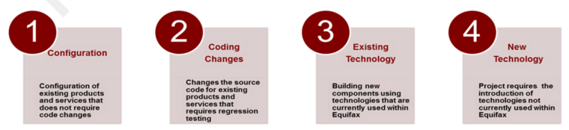

**Project Type:**

* 2- Coding Changes: Change the source code of existing products that require regression testing

Annex I - PRF Used for estimate

|  |  |
| --- | --- |
| ID | 1464 |
| Jira | CCS-1022 |
| Request Name | [Ignite Marketplace Extract/Refresh automation CIBC](https://sharepointhub.eis.equifax.com/apps/canadait/Canada%20IT%20Requests/_Layouts/listform.aspx?PageType=4&ListId=%7b89101F9B-5E97-49D1-A974-D42CE2A3D757%7d&ID=1464) |
| Requestor | [Oleksandra Ludan](https://sharepointhub.eis.equifax.com/apps/canadait/Canada%20IT%20Requests/_layouts/userdisp.aspx?ID=3622&RootFolder=*) |
| Request Owner |  |
| Request Source | Operations |
| Portfolio | Consumer |
| Assigned BA |  |
| Assigned SME |  |
| Assigned BTS | [Priya Kapoor](https://sharepointhub.eis.equifax.com/apps/canadait/Canada%20IT%20Requests/_layouts/userdisp.aspx?ID=3273&RootFolder=*) |
| Background | Portfolio insights is a marketplace app lanched in March, 2019. The app's backend database currently is comprised of 5 CSV files that are manually created and plugged into the spotfire visual DXPs prior to loading in production - size 400-500MB in total.  Request is to migrate PI2 backend datastore from CSVs to relational DBs tables to take advantage of speed and performance.  This will also automate the data refreshing of the PI2 apps which currently is a manual task of D&A data team monthly creating new CSVs and replugging them in the Spotfire DXPS. |
| Requirements | Please assist in extracting and sending information to the client in October, as well as assist in automating the process going forward by scheduling tasks associated with building files and sending to the clietn through SFTP on monthly basis.  Refer to the the following steps:  - Extract data from Cambrian PROD tables. - Move this data to Spotfire DEV to update the reports. - Promote data from Spotfire DEV to Spotfire PROD to refresh the Spotfire reports.  Thank you |
| Expected Intangible Benefits | Performance and Speet of portfolio insights products in Ignite marketplace |
| Expected Revenues | 500k |
| Expected Cost Savings | NA |
| Impact if no Action | Inability for product to get traction in market |
| Additional Information |  |
| ROM Session Date | 10/23/2019 |
| Attachments |  |